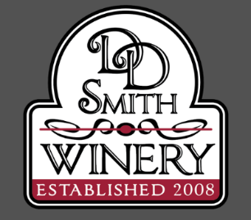
401 West Main St
Norwalk, OH 44857
Ph 419-577-0242
Rental Agreement

The following is the agreement between D & D Smith Winery LLC and ________________________
(Name)
For the rental of _______________________ beginning at __________________ (Time)
On________________and ending at _______________________________pm
(Day/Month/Year) (Time)

Available to rent:
- During Open Hours:
- Loft seats 30 ($100 rent + min tab $300),
- Partial ground floor area (back room) seats about 20 ($80 rent + $200 min tab),
- Outdoor pavilion seats 75+ ($125 rent + $500 min tab). All foods available at D&D Smith
- During Closed Hours (Mon-Tues) $150/hr with min tab of $850
- No foods brought in unless cake-prior approval needed.
- Purchase of alcohol; beer, hard ciders, mixed drinks available, tea, soda, lemonade, water.
- Our alcohol license does not allow any alcohol other than that sold by D&D Smith Winery, LLC to be on our premise inside or outside.
- Renter agrees to the following:
  - All beverages (alcohol and non-alcohol) are to be purchased from D&D Smith Winery.
  - First violation will result in a warning and removal of beverages to your vehicle
  - Second violation will result in your party being charged $250 and asked to leave
+ outstanding bill/tab. Initial_________
- Renter will be liable for any damages occurred during renting of our facility.
- Renter will be allowed to decorate minimally as long as it is first discussed with the facility owners on intention and materials used. No confetti or glitter, No nails or staples in walls
- A Credit Card will be given to D&D Smith Winery upon entering the facility, swiped, and given back with a tab held open for your party. You’ll need to review and sign with a minimum of 20% gratuity prior to leaving D&D Smith Winery.

__________________________________________________ _____________________________
Renter’s Signature Today’s Date

__________________________________________________ _____________________________
Renter’s Printer Name Phone # of Renter
Deposit of rental needed: $__________ paid Date:___________________________

